
Lesson 13: A Hit That Reacts
Unity
VIDEO GAME CREATION
This week: getting hit finally LOOKS like getting hit. A brief flash, then a small explosion, before the enemy disappears.
Open your own [YourName]Game project from Lesson 12 - don't start a new one.
Important: your score, lives, wave, and win/lose logic should all still work exactly as before. Today only changes how the enemy's removal LOOKS, not when your game-state actually changes.

Setup
- Open your [YourName]Game project from Lesson 12.
- Create a small Explosion prefab: a GameObject with a SpriteRenderer (Sprite = explosion_placeholder.png) and a script that calls Destroy(gameObject, 0.3f) in Start() - it cleans itself up automatically, no help needed from anything else.
- Import enemy_invader_white.png (this lesson's Assets folder) into your project - it's the same enemy silhouette as Lesson 4's sprite, pre-recolored solid white, used below for the hit flash.

Level 1 - Minimal (MVP)
On every hit, the enemy briefly flashes, and a small independent explosion effect appears and cleans itself up. Score, lives, wave, and win/lose logic are all unaffected.
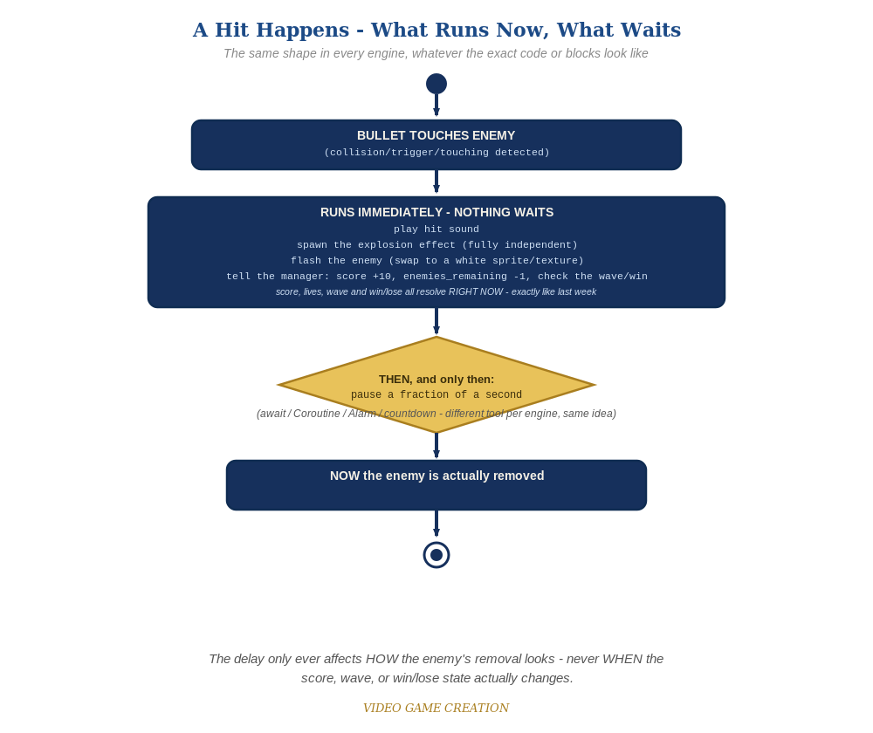
Everything in the top box happens the instant the hit is detected. Only the enemy's own removal - the very last step - waits for the pause to finish.
- On the Enemy prefab's script, find the function that currently detects a bullet hit (from Lesson 4) - it likely calls GameManager.RegisterKill() and Destroy(gameObject) immediately.
- Add public GameObject explosionPrefab, public SpriteRenderer spriteRenderer, and public Sprite flashSprite fields, and assign them in the Inspector (flashSprite = enemy_invader_white.png). Confirm the existing public AudioClip hitSound field from Lesson 4 is still there too - it stays, unchanged in how it's assigned, only moving to where it's called below.
- Rewrite the hit-handling as a Coroutine (code below) - Unity's first Coroutine this course - so it can pause partway through without freezing the whole game.
- Inside the Coroutine: Instantiate the explosion immediately (independent of everything else), swap spriteRenderer.sprite to flashSprite, play hitSound, then call the existing GameManager.RegisterKill() right away too - score/sound/wave/win-check must still happen at exactly the same instant as last week. Only AFTER that, yield return new WaitForSeconds(0.1f), then Destroy(gameObject) - that's the only line actually delayed. A color tint (spriteRenderer.color) won't work here: it multiplies the sprite's existing color, and multiplying any color by white leaves it completely unchanged - a genuinely white sprite is the only way to get a visible white flash on colored source art, the same reason Lesson 2's Recolor swaps sprites instead of tinting them. Also notice the hit sound now plays via AudioSource.PlayClipAtPoint(hitSound, Camera.main.transform.position) - at the camera, not the enemy's own position - matching the same pattern your other round-ending sounds already use, not Lesson 4's original (and, as of this lesson, corrected) transform.position placement.
- Change the hit-detection code to call StartCoroutine(HandleHit()) instead of calling the old logic directly.
- Press Play and play through a full round - each hit should flash the enemy white briefly, and a small burst should appear at that spot for a moment.
// Enemy's script (revised):
public GameObject explosionPrefab;
public SpriteRenderer spriteRenderer;
public Sprite flashSprite;
public AudioClip hitSound; // from Lesson 4 - stays, only its call site moves
void OnTriggerEnter2D(Collider2D other) {
if (other.CompareTag("Bullet")) {
Destroy(other.gameObject);
StartCoroutine(HandleHit());
}
}
IEnumerator HandleHit() {
Instantiate(explosionPrefab, transform.position, Quaternion.identity);
spriteRenderer.sprite = flashSprite;
AudioSource.PlayClipAtPoint(hitSound, Camera.main.transform.position);
GameManager.RegisterKill();
yield return new WaitForSeconds(0.1f);
Destroy(gameObject);
}

Alternate Path: Visual Scripting
The same flash-then-explode idea works in a Script Graph, using a Wait For Seconds node in place of a C# Coroutine.
- On the enemy's hit-handling graph, add an Instantiate node for the explosion prefab right at the start (unconditional, runs immediately).
- Set the SpriteRenderer's Sprite to flashSprite (enemy_invader_white.png) - not its Color, which would multiply against the enemy's existing color and produce no visible change - then keep your existing RegisterKill node running immediately after that, unchanged. Add a Wait For Seconds (0.1) node AFTER RegisterKill, with only the Destroy node moved to run after the wait - score/wave/win-check must not be delayed, only the enemy's actual removal.

Level 2 - Complete (Alpha/Beta)
The flash and explosion play correctly on every single hit, with no leftover explosions, no enemies stuck mid-flash, and no change to score/lives/wave timing.
- Play a full round: every single hit shows a flash and an explosion, with no enemy left stuck mid-flash.
- Confirm score, wave-clear, and win/lose all still happen at exactly the moments they did last week - yield only pauses this ONE Coroutine, nothing else in the game pauses.
- Confirm explosion prefabs never pile up in the Hierarchy - each one destroys itself via Destroy(gameObject, 0.3f), with no help from the Enemy.

Level 3 - Refined (Ready to Publish) - pick any that interest you
- Visual: instead of one flat instant swap, alternate spriteRenderer.sprite between flashSprite and the enemy's normal sprite 2-3 times across the 0.1 seconds (with tiny waits between) for a flicker instead of a single snap.
- Visual: scale the explosion prefab up slightly over its lifetime with a small script using Time.deltaTime, so it feels like it's expanding.
- Structure: notice the explosion prefab knows nothing about score, lives, or waves - it's a fully self-contained object, the same discipline as this course's bullets and enemies.

If Something's Wrong
- Enemy vanishes instantly, no flash visible: confirm the Coroutine is actually being started (StartCoroutine(HandleHit())), not the old code still calling RegisterKill()/Destroy() directly.
- Enemy disappears but never visibly turns white: confirm flashSprite is actually assigned in the Inspector to enemy_invader_white.png, not left empty or still pointing at the normal sprite.
- Explosion never appears: confirm explosionPrefab is actually assigned in the Inspector, not left empty.
- Two bullets can double-trigger the same enemy: confirm other.gameObject is destroyed at the top of OnTriggerEnter2D, before StartCoroutine runs, so a second overlapping bullet can't also collide.
- Hit sound is missing or barely audible: confirm hitSound is actually assigned in the Inspector, and that the call uses Camera.main.transform.position, not transform.position - PlayClipAtPoint() always creates a 3D audio source with real distance rolloff, so a sound played at the enemy's own position (far from the camera/listener) can end up almost inaudible even though it's technically playing.

Want More?
Student Resource List > Unity section, or learn.unity.com

